CompTia A+ Assessment

Hardware Components & System Assembly

Section A — Concept Application

S1 SCENARIO: You are setting up a new office workstation and need to choose the core hardware for it from a supplier's parts list.
Question: Explain the process of selecting a compatible motherboard, CPU, RAM, and storage device for a new office workstation, and justify how you would confirm they will work together.

Selecting compatible components for a new office workstation involves checking the compatibility, performance, and requirements of each component before purchasing.
- Select the Motherboard:
Choose a motherboard with a suitable CPU socket and chipset. It should support the required RAM type and speed, have enough RAM slots, and provide the required storage interfaces such as SATA or M.2/NVMe.
- Select the CPU:
Select a CPU that uses the same socket as the motherboard. Check the motherboard manufacturer's CPU support list to confirm that the processor is supported. For an office workstation, a modern multi-core CPU with good power efficiency is generally suitable.
- Select RAM:
Choose RAM that matches the motherboard's supported DDR generation, such as DDR4 or DDR5. Check the maximum supported capacity and speed. For example, if the motherboard supports DDR5, DDR4 RAM cannot be installed because the two types are physically and electrically different.
- Select Storage Device:
Choose storage based on the motherboard's available interfaces. An M.2 NVMe SSD requires an appropriate M.2 slot with NVMe/PCIe support, while a SATA SSD requires a SATA port and SATA cable.
- Confirm Compatibility:
Before purchasing, check the motherboard manufacturer's specifications and CPU support list, RAM compatibility information, and storage specifications. Also verify that the motherboard has the required slots and connectors.
- Test the Components:
After assembly, install the CPU, RAM, and storage correctly and enter the BIOS/UEFI to confirm that the CPU, total RAM, and storage device are detected. Finally, install the operating system and run basic tests to ensure the workstation works reliably.

S2 SCENARIO: You are advising a client whose employees mainly run office and productivity applications on their workstations.
Question: Explain the differences between HDD, SSD, and NVMe storage, and recommend the most suitable option for this workload, giving technical reasons for your choice.

HDD, SSD, and NVMe are different types of storage devices. They mainly differ in the way they store data, their speed, cost, and overall performance.
Feature | HDD | SATA SSD | NVMe SSD
Technology | Magnetic disk | NAND flash | NAND flash
Speed | Slow | Fast | Very fast
Moving parts | Yes | No | No
Interface | SATA | SATA | PCIe
Cost per GB | Low | Medium | Higher
Best use | Bulk storage/backup | General office use | High-performance workloads

Recommendation:
For this office workstation, I would recommend an NVMe SSD as the main storage device, preferably around 500 GB to 1 TB. It will provide faster boot times, quicker application loading, faster file transfers, and better overall system performance. It is also useful when working with large files or using multiple applications at the same time. If more storage is needed at a lower cost, an HDD can be added separately for bulk storage or backups.

S3 SCENARIO: You are configuring a workstation that will run mildly graphics-intensive design software for several hours a day.
Question: Explain the role of the GPU and the cooling system in maintaining performance and stability under this kind of sustained load.
The GPU (Graphics Processing Unit) and cooling system both play an important role in maintaining the performance and stability of a computer, especially when it is working under a sustained load.
- Role of the GPU:
The GPU is mainly responsible for handling graphics and other tasks that require parallel processing. In an office workstation, it may be used for tasks such as graphic design, video editing, data visualization, or applications that require GPU acceleration. A suitable GPU helps these tasks run smoothly without putting too much load on the CPU.
- Role of the Cooling System:
The cooling system removes the heat produced by the CPU, GPU, and other components while they are working. It usually includes components such as CPU heatsinks, fans, thermal paste, and cabinet airflow. Good cooling prevents the components from becoming too hot during long periods of use.
- Maintaining Performance:
When components become too hot, they may automatically reduce their speed to lower the temperature. This is called thermal throttling. Proper cooling helps prevent thermal throttling, allowing the CPU and GPU to maintain their performance for a longer time.
- Maintaining Stability:
Excessive heat can cause system slowdowns, crashes, unexpected shutdowns, or even damage to components over time. A proper cooling system keeps temperatures within safe operating limits and improves the overall stability and lifespan of the workstation.

S4 SCENARIO: You are assembling a PC from components sourced from three different vendors.
Question: Explain why hardware compatibility matters when assembling a computer, and identify potential issues that could arise from incompatible components.

Hardware compatibility is important when assembling a computer because all the components need to work together properly. Before buying or installing any component, we should check whether it is supported by the motherboard and other hardware.
- CPU and Motherboard Compatibility:
The CPU must have the correct socket type supported by the motherboard. If the socket is different, the CPU cannot be installed or used.
- RAM Compatibility:
The RAM must match the type supported by the motherboard, such as DDR4 or DDR5. The motherboard should also support the RAM's capacity and speed.
- Storage Compatibility:
The motherboard must have the correct interface for the storage device. For example, an NVMe SSD requires a suitable M.2 PCIe slot, while a SATA drive requires a SATA port.
- Power Supply Compatibility:
The power supply should provide enough wattage and have the required connectors for the motherboard, CPU, GPU, and other components.
- Potential Problems:
Using incompatible components can cause problems such as the computer not starting, components not being detected, system crashes, poor performance, overheating, or even hardware damage in some cases.

S5 SCENARIO: You are finalizing the build and need to connect the power supply unit (PSU) to the motherboard, GPU, and storage devices before first boot.
Question: Explain how you would choose an appropriately rated PSU for this build and describe the safety and connection checks you would carry out before powering it on.

Choosing the correct Power Supply Unit (PSU) is important because it provides power to all the components of the computer. The PSU should have enough power and the correct connectors to support the complete system.
- Calculate the Power Requirement:
First, I would check the power requirements of the CPU, GPU, motherboard, storage devices, and other components. I would then choose a PSU with some extra capacity, usually around 20–30% more than the estimated system requirement, so it can handle peak loads and future upgrades.
- Check the PSU Rating:
I would select a PSU from a reliable manufacturer with a suitable 80 PLUS efficiency rating, such as 80 PLUS Bronze, Gold, or better. A good-quality PSU provides stable power and reduces energy wastage.
- Check Required Connectors:
I would make sure the PSU has the required connectors, such as the 24-pin motherboard connector, CPU power connector, PCIe/GPU connectors, and SATA power connectors for storage devices.
- Safety Checks Before Powering On:
Before switching on the computer, I would make sure the power cable is disconnected and check that all components are properly installed. I would also ensure that there are no loose screws, exposed wires, damaged cables, or signs of a short circuit inside the cabinet.
- Connection Checks:
I would verify that the motherboard's 24-pin and CPU power connectors are firmly connected. I would also check the GPU power connector, SATA power cables, and any other required connections. All cables should be properly seated and kept away from fans.
- Final Check:
Finally, I would ensure that the PSU voltage setting, if applicable, is correct for the local power supply, connect the power cable, and switch on the system. I would then check that the system starts normally and that there are no unusual sounds, smells, or overheating issues.

S6 SCENARIO: You are handing over a freshly assembled workstation to the client and need to confirm it is ready for use.
Question: Explain the checks you would perform to confirm the system passes POST successfully, and what you would do if it did not.

POST (Power-On Self-Test) is a process performed by the computer when it is switched on to check whether the basic hardware components are working properly before the operating system starts.
- Power On the System:
First, I would switch on the computer and check whether the fans start spinning, power LED turns on, and the system responds normally.
- Check the Display:
I would check whether the monitor displays the POST/boot screen and whether the system shows the motherboard or manufacturer logo.
- Check RAM and CPU Detection:
I would enter the BIOS/UEFI and confirm that the CPU and the correct amount of RAM are detected properly.
- Check Storage Devices:
I would verify in BIOS/UEFI that the SSD or HDD is detected and that the correct boot device is selected.
- Check POST Beeps or Error Indicators:
If there is a hardware problem, the motherboard may produce beep codes or show diagnostic LEDs. These can help identify problems with RAM, CPU, GPU, or other components.
If POST Fails:
If the system does not pass POST, I would first switch off and disconnect the power. Then I would check that the RAM, CPU power connector, GPU, and other important cables are properly seated. I would also try reseating the RAM or testing one RAM module at a time, if appropriate.
Next, I would check the motherboard's diagnostic LEDs or beep-code information to identify the faulty component. I would also check for loose connections, incorrect component installation, or signs of a short circuit. After fixing the issue, I would power on the system again and confirm that it completes POST successfully.

Section B — Practical Coding Tasks

Task 1: Component Identification & Functions.
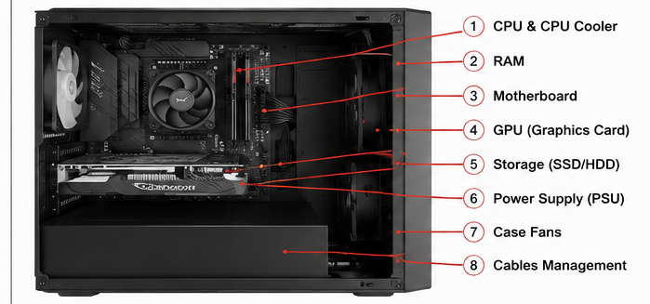

Component | Function | Make/Model or Key Specification
CPU & CPU Cooler | The CPU is the main processing unit that executes instructions and performs calculations. The CPU cooler removes the heat produced by the processor and prevents overheating. | CPU model is not visible; air-based CPU cooler shown
RAM | RAM temporarily stores the data and programs currently being used by the computer. It helps the system run applications and multitask smoothly. | RAM capacity/model is not visible
Motherboard | The motherboard is the main circuit board that connects the CPU, RAM, GPU, storage, and other hardware components and allows them to communicate with each other. | Motherboard model is not visible
GPU (Graphics Card) | The GPU processes graphics, images, and video and sends the output to the monitor. It is useful for graphics-intensive applications and video processing. | GPU model/VRAM is not visible
Storage (SSD/HDD) | The storage device permanently stores the operating system, applications, documents, and other files. | Exact type/capacity is not visible
Power Supply (PSU) | The PSU converts electricity from the wall outlet into the appropriate power required by the computer's components. | Wattage/model is not visible
Case Fans | Case fans move air through the computer case, helping remove heat and maintain proper airflow. | Fan size/model is not visible
Cable Management | Cable management keeps the cables organized and away from fans and other components. It improves airflow and makes maintenance easier. | —

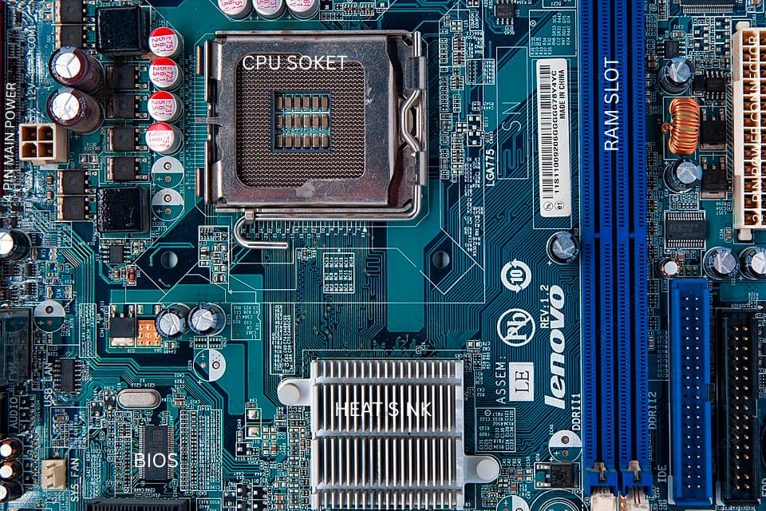
Task 2: Motherboard Ports & Socket Identification

Motherboard:
The motherboard is the main circuit board of a computer. It connects the CPU, RAM, storage devices, expansion cards, power supply, and other peripherals.
1. CPU Socket:
The CPU socket is the location where the processor is installed. The socket type depends on the motherboard model. It provides the electrical and physical connection between the CPU and motherboard.
Compatible CPU: The compatible CPU family depends on the socket type and motherboard chipset.
2. RAM/DIMM Slots:
These slots are used to install RAM modules. RAM provides temporary working memory for the operating system and applications.
3. SATA Ports:
SATA ports are used to connect SATA storage devices such as HDDs, SATA SSDs, and optical drives to the motherboard.
4. 24-Pin ATX Power Connector:
This is the main motherboard power connector. It supplies power from the SMPS/Power Supply Unit to the motherboard.
5. CPU Power Connector:
The 4-pin/8-pin CPU power connector supplies additional power directly to the processor.
6. PCIe Expansion Slots:
PCI Express slots are used to install expansion cards such as:
- GPU/Graphics card – provides graphics processing.
- Wi-Fi/Bluetooth card – provides wireless connectivity.
- Sound card – provides enhanced audio.
- Other expansion cards.
7. M.2 Slot:
The M.2 slot is used mainly for installing an M.2 SSD, which provides high-speed storage. Some M.2 slots can also support Wi-Fi/Bluetooth modules depending on the motherboard.
8. USB Headers:
Internal USB headers connect the motherboard to the computer case's front USB ports.
9. Front-Panel Headers:
These connect the computer case's Power button, Reset button, Power LED, and HDD LED to the motherboard.
10. Front Audio Header:
The HD_AUDIO header connects the case's front headphone and microphone ports.
11. CMOS Battery:
The CMOS battery maintains BIOS/UEFI settings and the system clock when the computer is powered off.
12. Rear I/O Ports:
The rear side generally contains ports such as:
- USB ports
- Ethernet/LAN port
- Audio ports
- HDMI/DisplayPort/VGA, if supported
- PS/2 keyboard/mouse port, on some motherboards

Task 3: RAM & Storage Installation

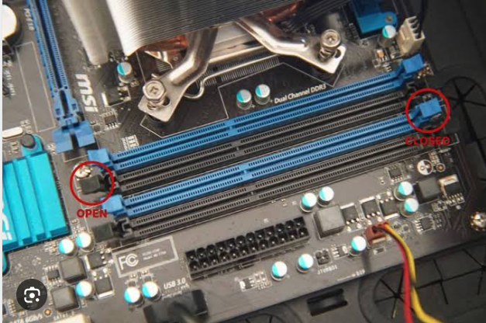
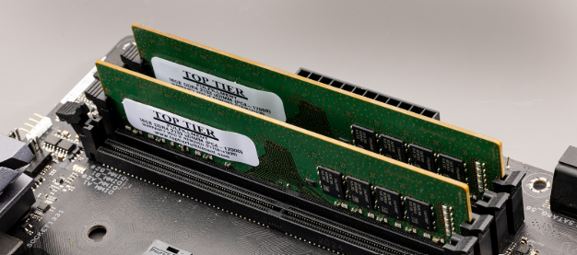
To safely remove and reinstall a RAM module and a storage device while following proper hardware-handling and ESD safety procedures.
1. ESD Precautions:
- Shut down the computer and disconnect the power cable.
- Press the power button for a few seconds to discharge remaining power.
- Avoid touching the gold contacts of the RAM or storage device.
- Hold components by their edges.
- Use an anti-static wrist strap or touch a grounded metal part of the computer case before handling components.
2. RAM Removal:
- Open the computer case and locate the RAM/DIMM slot on the motherboard.
- Push the locking clips on both sides of the RAM slot outward.
- Hold the RAM module by its edges and gently remove it from the slot.
- Keep the RAM on an anti-static surface.
3. RAM Reinstallation:
- Check the notch on the RAM module and align it with the notch in the RAM slot.
- Press the RAM module firmly and evenly into the slot.
- The locking clips should automatically move into position and hold the RAM securely.
- Confirm that the RAM is properly seated and both locking clips are engaged.
4. Storage Device Removal:
- Identify the installed storage device.
- If it is a SATA drive, disconnect the SATA data cable and SATA power cable, then remove the drive from its mounting position.
- If it is an NVMe M.2 SSD, remove its retaining screw and carefully slide the SSD out of the M.2 slot.
5. Storage Reinstallation:
- For a SATA drive, reconnect the SATA data and power cables securely.
- For an NVMe SSD, insert it into the M.2 slot at an angle and secure it with the retaining screw.
- Make sure the storage device is firmly connected.
6. Verification After Reinstallation:
- Reconnect the power cable and start the computer.
- Enter BIOS/UEFI or Windows.
- Check that the installed RAM capacity is detected correctly.
- Check File Explorer/Disk Management or BIOS/UEFI to confirm that the storage device is detected.

Task 4: Full Desktop PC Assembly
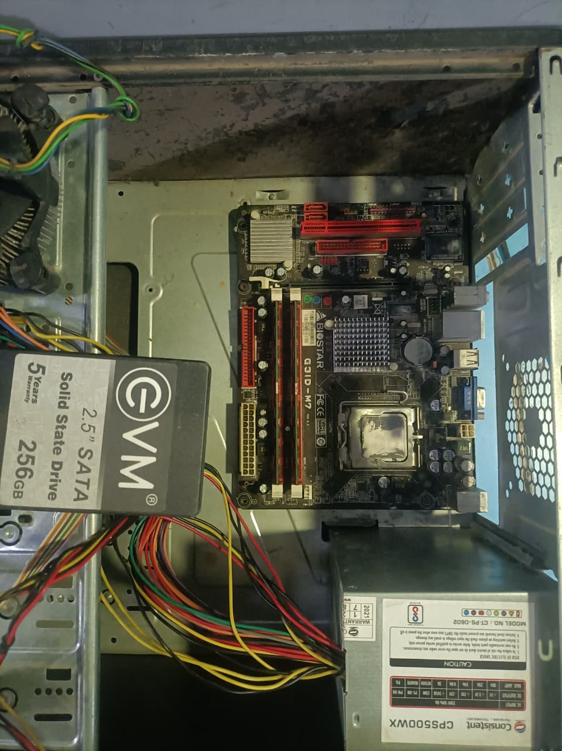
Step 1: Prepare the workplace
- Shut down and unplug all equipment.
- Use an anti-static wrist strap if available.
- Keep screws and components organized.
Step 2: Install the CPU
- Open the CPU socket.
- Align the CPU correctly.
- Place it gently into the socket.
- Lock the socket mechanism.
Step 3: Apply thermal paste
Apply a small amount of thermal paste if the CPU cooler does not already have thermal paste applied.
Step 4: Install CPU cooler
- Place the cooler on the CPU.
- Secure it properly.
- Connect the CPU fan cable to the motherboard CPU_FAN header.
Step 5: Install RAM
- Open the RAM slot clips.
- Align the notch on the RAM module.
- Press it down until properly seated.
Step 6: Install motherboard
Place the motherboard inside the case and secure it with the correct screws.
Step 7: Install storage
Install the:
- HDD, or
- SATA SSD, or
- M.2/NVMe SSD.
Step 8: Install PSU
Place the PSU in the case and secure it.
Step 9: Connect power cables
Connect the required:
- 24-pin motherboard power.
- CPU power cable.
- GPU power cable, if required.
- Storage power cables.
Step 10: Connect front-panel cables
Connect:
- Power switch.
- Reset switch.
- Power LED.
- HDD LED.
- USB.
- Audio.
Step 11: Install GPU
If required:
- Insert the graphics card into the appropriate PCIe slot.
- Secure it.
- Connect its power cable if required.
Step 12: Final inspection
Check that:
- RAM is properly installed.
- CPU cooler is connected.
- Power cables are connected.
- No loose screws are inside.
- Fans can rotate freely.
Step 13: Power on
Turn on the computer and check whether it successfully completes POST.

Section C — Mini Capstone Project

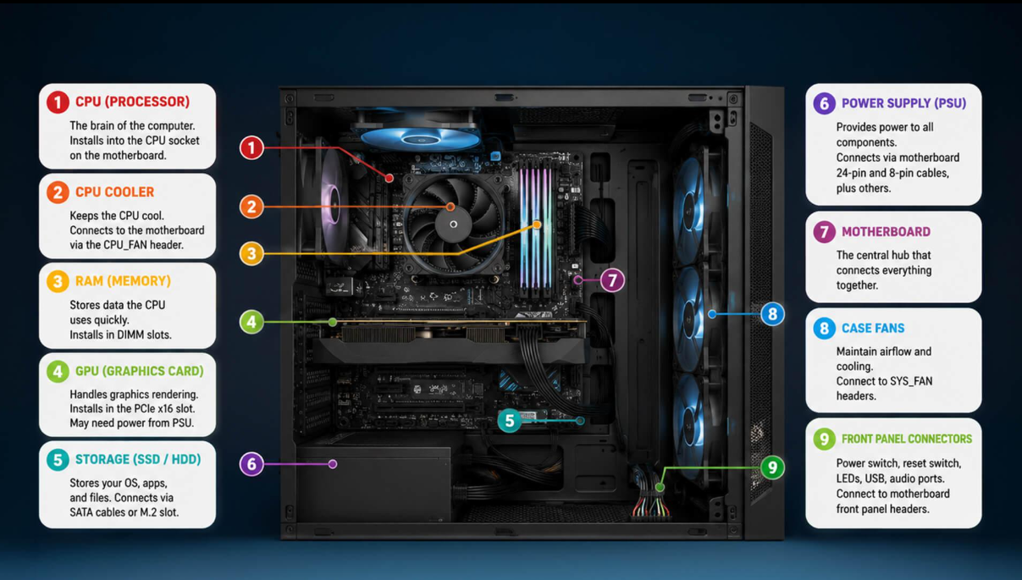
Workstation Deployment & Boot-Failure Diagnosis
Objective:
The objective of this project is to assemble or inspect a workstation, identify possible boot failures and hardware detection problems, verify component installation and compatibility, and prepare a checklist for reliable deployment.
1. Three Hardware Components to Check First When a Newly Assembled PC Fails to Boot
When a newly assembled PC does not start or does not display anything, I would first check the following three components:
1. Power Supply Unit (PSU)
The PSU should be checked first because it supplies power to the motherboard, CPU, GPU, storage devices, and other components. I would check whether the PSU is switched on and whether the 24-pin ATX and CPU 4/8-pin power connectors are properly connected.
2. RAM
Incorrectly installed or incompatible RAM can prevent a computer from completing POST. I would remove and reinstall the RAM, make sure it is in the correct slot, and check that the locking clips are properly engaged.
3. CPU and CPU Power Connection
The CPU must be correctly installed and compatible with the motherboard. I would check the CPU seating, CPU socket, cooler installation, and the CPU power connector. An incompatible CPU or incorrectly connected CPU power cable can cause the system to fail to boot.

2. Motherboard–CPU Compatibility
Motherboard and CPU compatibility is important because the processor must match the CPU socket and chipset supported by the motherboard.
The motherboard used in the workstation has a specific CPU socket. The processor must be from a CPU family supported by that socket and motherboard chipset. Even if a CPU physically fits into a socket, it may not work if the motherboard BIOS or chipset does not support it.
For the assembled system, I would verify:
- CPU socket type on the motherboard.
- CPU model and generation.
- Motherboard chipset compatibility.
- BIOS/UEFI support for the CPU.
- Required CPU power connection.
- Manufacturer's supported CPU list.

3. Verification of RAM and Storage Installation
RAM Verification
To verify that RAM is installed correctly:
- Turn off and disconnect the PC from power.
- Check that the RAM notch is correctly aligned with the motherboard slot.
- Press the RAM module firmly until the locking clips click into place.
- Power on the computer.
- Enter the BIOS/UEFI and check the detected RAM capacity.
- If 8 GB RAM is installed, for example, BIOS should normally report approximately 8 GB of installed memory.
During POST, some systems may also provide beep codes or diagnostic LEDs if RAM is missing or incorrectly installed.
Storage Verification
For a SATA storage device:
- Check the SATA data cable connection to the motherboard.
- Check the SATA power connection from the PSU.
- Confirm that the drive appears in BIOS/UEFI.
- In Windows, check Disk Management/File Explorer to confirm that the storage device is detected.
For an NVMe M.2 SSD:
- Ensure that the SSD is correctly inserted into the M.2 slot.
- Secure it using the retaining screw.
- Check BIOS/UEFI to confirm that the NVMe drive is detected.

4. Hardware-Installation Checklist
The following checklist can help prevent hardware failures during future workstation deployments:
No. | Checklist Step
1 | Check compatibility between CPU, motherboard, RAM, storage, GPU, and PSU before installation.
2 | Follow ESD precautions and handle components carefully by their edges.
3 | Check all connections, especially the 24-pin motherboard and CPU power connectors.
4 | Ensure RAM and GPU are completely seated and their locking mechanisms are engaged.
5 | Verify SATA/M.2 storage connections before closing the case.
6 | Perform a BIOS/POST test before final deployment.
This checklist reduces installation mistakes and helps identify problems before computers are deployed in the lab.

5. Why SSDs Should Be Used Instead of HDDs in Modern Office Workstations
SSDs are more suitable than traditional HDDs for modern office workstations because they provide much faster data access and system performance.
Advantages of SSDs:
- Faster boot time: The operating system starts much faster.
- Faster application loading: Programs such as browsers, office software, and development tools open quickly.
- Better responsiveness: Files can be accessed and transferred more quickly.
- No moving mechanical parts: SSDs are more resistant to physical shock and vibration.
- Lower noise: SSDs operate silently.
- Lower power consumption: They generally consume less power than mechanical HDDs.
- Better reliability for frequent access: They avoid mechanical wear associated with spinning disks.
For the ABC Solutions computer lab, SSDs would improve productivity because multiple users may regularly start computers, open applications, access files, and perform development or IT-related tasks. Faster boot and application-loading times would reduce waiting time and provide a smoother workstation experience.

Section D — AI-Augmented Learning

STEP 1 — BUILD WITH AI
I used ChatGPT as an AI tool to create a troubleshooting checklist for a desktop PC that fails to boot immediately after assembly.
Desktop PC Boot-Failure Troubleshooting Checklist
Scenario: ABC Solutions has assembled new workstations, but some systems fail to start or show hardware detection errors.
Step 1: Ensure Safety and ESD Protection
☐ Switch off the PC and disconnect the power cable.
☐ Use an anti-static wrist strap or touch a grounded metal part of the case.
☐ Do not handle components by their gold contacts.
Step 2: Check the PSU and Power Connections
☐ Confirm the PSU switch is in the ON position.
☐ Check that the power cable is connected properly.
☐ Check the 24-pin ATX motherboard power connector.
☐ Check the 4/8-pin CPU power connector.
☐ If a GPU requires additional power, check its PCIe power cable.
If there is no power: troubleshoot the PSU and power connections before moving to other components.
Step 3: Check the Motherboard
☐ Check that the motherboard is correctly mounted in the case.
☐ Check for loose screws or possible short circuits.
☐ Check motherboard diagnostic LEDs or beep codes, if available.
☐ Confirm that the CPU, RAM and other components are connected correctly.
Step 4: Check the RAM
☐ Switch off and disconnect power before reseating RAM.
☐ Remove and reinstall the RAM module.
☐ Ensure the notch is correctly aligned with the RAM slot.
☐ Confirm that the locking clips are engaged.
☐ If multiple RAM modules are installed, test one module at a time if necessary.
If the PC fails POST or shows a memory error: RAM seating, compatibility, or the RAM module itself should be investigated.
Step 5: Check the CPU
☐ Confirm that the CPU is correctly installed in the socket.
☐ Check that the CPU socket and processor are compatible.
☐ Ensure the CPU cooler is properly installed.
☐ Confirm that the CPU fan is connected to the CPU_FAN header.
Step 6: Check Storage
☐ For SATA drives, check both the SATA data and SATA power cables.
☐ For an NVMe SSD, ensure it is correctly inserted into the M.2 slot and secured.
☐ Enter BIOS/UEFI and confirm that the storage device is detected.
A missing storage device may prevent the operating system from booting, but it normally should not prevent the computer from reaching BIOS/UEFI/POST.
Step 7: Check BIOS/UEFI
☐ Enter BIOS/UEFI after powering on.
☐ Confirm that the CPU and RAM are detected.
☐ Confirm that the storage device is detected.
☐ Check whether the correct boot device is selected.
Step 8: Perform Final Testing
☐ Reconnect all required components.
☐ Power on the PC.
☐ Confirm that it successfully completes POST.
☐ Confirm that BIOS/UEFI detects RAM and storage.
☐ Confirm that the operating system starts successfully.

Simple Decision Flow
PC fails to boot
↓
Follow ESD/safety precautions
↓
Check PSU + 24-pin + CPU power
→ No power → Fix PSU/power connection
↓
Check motherboard/diagnostic LEDs
↓
Check and reseat RAM
→ Memory error → Test RAM/module/slot
↓
Check CPU installation & compatibility
↓
Check SATA/M.2 storage connections
↓
Enter BIOS/UEFI
↓
Are RAM + storage detected?
→ No → Reseat/check compatibility/connections
→ Yes → Check boot device/OS
↓
Successful POST and OS boot
Application to ABC Solutions Scenario
In the ABC Solutions scenario, the troubleshooting process would begin with power connections, motherboard, RAM, CPU, and storage rather than immediately assuming an operating-system problem.
For example, if a newly assembled workstation had a hardware detection error caused by incorrectly seated RAM, Step 4 (Check the RAM) would identify the problem. If the storage device was not detected, Step 6 (Check Storage) would identify an incorrectly connected SATA cable or improperly installed M.2 SSD.

STEP 2 — TEST & DEBUG WITHOUT AI
After reviewing the AI-generated checklist myself, I identified one important improvement:
Problem found:
The original troubleshooting approach could allow a technician to start checking individual components before explicitly confirming that the system was safe to work on.
Correction made:
I placed ESD and power-safety precautions as Step 1, before opening the case or touching any internal components.
I also confirmed that physical connections and POST should be checked before troubleshooting software, because a newly assembled computer with incorrectly installed RAM, CPU, PSU, or storage should first be diagnosed at the hardware level.

